# PRACTICE PROGRAM MODULE -1

## SECTION-4.3

1.

**PROGRAM CODE:**

import java.util.Scanner;

public class TriangleAreaCalculator {

public static void main(String[] args) {

Scanner scanner = new Scanner(System.in);

System.out.print("Enter the base of the triangle: ");

double base = scanner.nextDouble();

System.out.print("Enter the height of the triangle: ");

double height = scanner.nextDouble();

double area = 0.5 * base * height;

System.out.println("The area of the triangle is: " + area);

scanner.close();

}

}

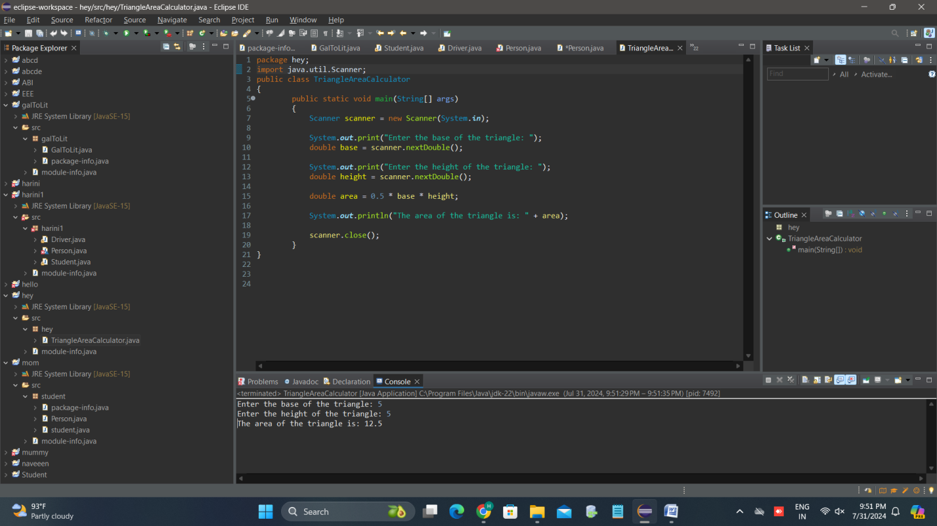

2.

**PROGRAM CODE:**

public class MathFormulas {

public static void main(String[] args) {

double x = 10.0;

double y = 5.0;

double z = 20.0;

double a = Math.sqrt((Math.pow(x, 5) - 6) / 4);

double b = Math.pow(x, y) - 6 * x;

double c = 4 * Math.cos(z / 5) - Math.sin(Math.pow(x, 2));

double d = Math.pow(x, 4) - Math.sqrt(6 * x - Math.pow(y, 3));

double e = 1 / (y - 1 / (x - 2 * y));

double f = 7 * Math.cos(Math.sqrt(5) - Math.sin(Math.sqrt(3 * x - 4)));

System.out.println("a = " + a);

System.out.println("b = " + b);

System.out.println("c = " + c);

System.out.println("d = " + d);

System.out.println("e = " + e);

System.out.println("f = " + f);

**}**

**}**

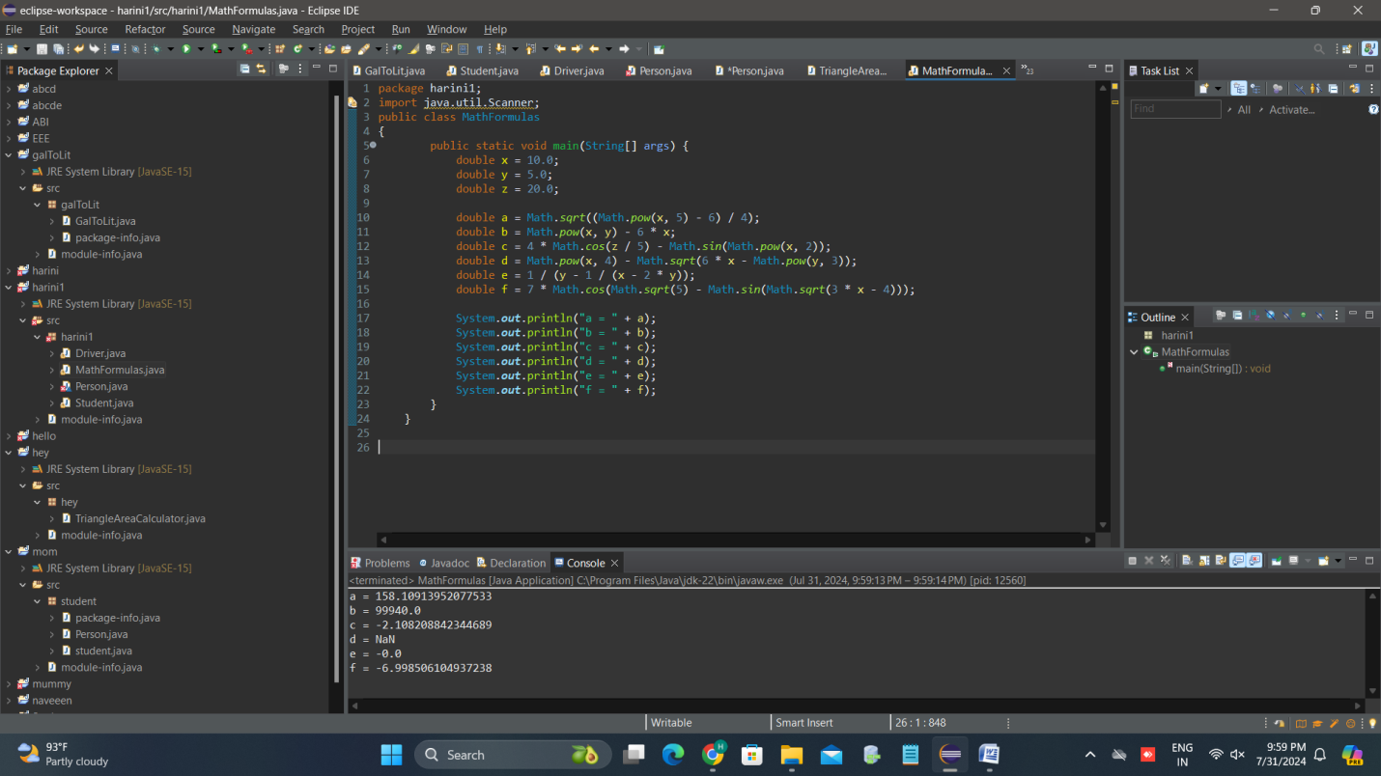

3.

**PROGRAM CODE:**

import java.util.Scanner;

public class FieldTrip {

public static void main(String[] args) {

Scanner scanner = new Scanner(System.in);

System.out.print("Enter the number of people signed up for the field trip: ");

int totalPeople = scanner.nextInt();

int busCapacity = 45;

int busesNeeded = totalPeople / busCapacity;

int peopleInVans = totalPeople % busCapacity;

System.out.println("Number of buses needed: " + busesNeeded);

System.out.println("Number of people that will need to ride in vans: " + peopleInVans);

scanner.close();

}

}

